Q7 - Diagnose, redesign and validate
Solution selected: Q1 - the railway e-ticket generator that builds each ticket with the + operator inside a loop. The evidence from Q1 shows a clear limitation as ticket size grows, so it is diagnosed, redesigned and validated below.

A. Diagnose the bottleneck
- Where time and memory go: in the original, a 100-ticket x 2,000-line workload allocated about 4,200 MB and took about 290 ms, against about 26 MB / 6 ms for the StringBuilder version (from the Q7 output).
- Which operation grows: the += inside the loop. Per-ticket allocation went from about 26 KB (50 lines) to about 42 MB (2,000 lines): lines grew 40 times but allocation about 1,600 times = 40 squared, so it grows as n squared.
- Unnecessary repeated work: the already-built text is copied again on every +=; temporary Strings are created for every field expression ("P" + i + ":" + ...); the "naive fix" still concatenates with + inside append(...) and allocates a new builder with default capacity for every ticket (repeated array growth).
- Characteristic of the class causing it: String is immutable, so any change makes a new object and copies all characters.

B. Design objective
- Produce byte-identical tickets (correctness preserved).
- Cut memory allocated per ticket by at least 80% compared with the original (target: only the one final String per ticket plus small overhead).
- Make cost grow linearly with ticket size (O(n)); for 2,000-line tickets be at least 10 times faster than the original.
- No increase in code risk for the multithreaded server: no shared mutable builder.

C. Design the revised solution
- What changed: (1) one StringBuilder is reused for every ticket (setLength(0) resets it but keeps its big internal array); (2) it is pre-sized with ensureCapacity(lines x 28 + 16) so the array never regrows; (3) fields are appended directly with append(int), append(char), append(String) - no + anywhere, so no temporary Strings; (4) only toString() creates one String per ticket.
- Property exploited: StringBuilder is mutable with amortised O(1) append, and its capacity is kept after setLength(0).
- Operations avoided: repeated copying of the growing prefix (O(n squared) -> O(n)); creation of per-field temporary Strings; per-ticket builder allocation and array regrowth.
- Additional memory / preprocessing: the reusable buffer stays allocated at the size of the largest ticket (e.g. 56 KB for 2,000 lines), and we need an estimate of the ticket size for pre-sizing.
- New trade-offs: the buffer is not thread-safe. In the booking server give each thread its own: ThreadLocal<StringBuilder> (no locking, no sharing). Code is longer and less readable than +; the buffer must be shrunk if one huge ticket arrives (so memory is not held forever).
Design representation (pseudocode):
PSEUDOCODE / CLASS SKETCH
class TicketPrinter {
private final StringBuilder buf = new StringBuilder(64 * 1024); // one per thread

String print(Booking b) {
buf.setLength(0); // reuse the same array
buf.ensureCapacity(b.lines() * 28 + 16); // pre-size, avoid regrowth
buf.append("PNR:").append(b.pnr()).append('\n');
for each passenger line i in b:
buf.append('P').append(i).append(':').append(name)... // no "+" at all
return buf.toString(); // the only new String
}
}

// server side: static final ThreadLocal<TicketPrinter> PRINTER = ThreadLocal.withInitial(TicketPrinter::new);

D. Predict before implementing
Prediction (made before running the redesigned version): (1) bytes allocated per ticket will drop by more than 80% against the original and by about 5x against the naive fix; (2) time against the original will improve by more than 10x for 2,000-line tickets and about 1.5-4x for 50-line tickets; (3) time against the naive StringBuilder fix will change only slightly (both are O(n)), so the main improvement will be in memory/allocation, not time.

E. Implement and validate
Q7/Q7_Redesign.java
import java.lang.management.ManagementFactory;

/**
* Q7 - Diagnose, redesign and validate the Q1 ticket generator.
* Original : String += inside a loop, building each ticket line with + as well
* Naive fix : new StringBuilder per ticket, but still concatenating with + inside append()
* Redesign : ONE reusable, pre-sized StringBuilder; append primitives directly (no + at all)
* Run: java Q7_Redesign.java
*/
public class Q7_Redesign {

static final String[] NAMES = {"Arun", "Divya", "Meena", "Ravi", "Kumar", "Lata", "Asha", "John"};
static final String[] COACHES = {"S1", "S2", "B1", "A1"};

// ---------- ORIGINAL ----------
static String original(int pnr, int lines) {
String t = "PNR:" + pnr + "\n";
for (int i = 0; i < lines; i++) {
t += "P" + i + ":" + NAMES[i % 8] + "," + COACHES[i % 4] + "," + (i % 72 + 1) + "," + (500 + i) + ";\n";
}
return t;
}

// ---------- NAIVE FIX (replaces the class but keeps the + habit) ----------
static String naive(int pnr, int lines) {
StringBuilder sb = new StringBuilder();
sb.append("PNR:" + pnr + "\n");
for (int i = 0; i < lines; i++) {
sb.append("P" + i + ":" + NAMES[i % 8] + "," + COACHES[i % 4] + "," + (i % 72 + 1) + "," + (500 + i) + ";\n");
}
return sb.toString();
}

// ---------- REDESIGN: reusable, pre-sized builder, no intermediate Strings ----------
static final StringBuilder BUF = new StringBuilder(64 * 1024); // allocated once, reused for every ticket

static String redesigned(int pnr, int lines) {
StringBuilder sb = BUF;
sb.setLength(0); // reset, keeps the big internal array
sb.ensureCapacity(lines * 28 + 16); // estimated size: avoids repeated array growth
sb.append("PNR:").append(pnr).append('\n');
for (int i = 0; i < lines; i++) {
sb.append('P').append(i).append(':').append(NAMES[i % 8]).append(',')
.append(COACHES[i % 4]).append(',').append(i % 72 + 1).append(',')
.append(500 + i).append(";\n");
}
return sb.toString(); // the only String created per ticket
}

// ---------- measurement ----------
interface Gen { String make(int pnr, int lines); }
static final com.sun.management.ThreadMXBean TMX =
(com.sun.management.ThreadMXBean) ManagementFactory.getThreadMXBean();

static long work(Gen g, int tickets, int lines) {
long sum = 0;
for (int t = 0; t < tickets; t++) sum += g.make(1000 + t, lines).length();
return sum;
}

@SuppressWarnings("deprecation")
static void measure(String name, Gen g, int tickets, int lines, int runs) {
work(g, Math.max(1, tickets / 10), lines); // warm-up
double avgMs = 0; long bytes = 0;
for (int r = 0; r < runs; r++) {
System.gc();
long a0 = TMX.getThreadAllocatedBytes(Thread.currentThread().getId());
long t0 = System.nanoTime();
work(g, tickets, lines);
avgMs += (System.nanoTime() - t0) / 1e6;
bytes = TMX.getThreadAllocatedBytes(Thread.currentThread().getId()) - a0;
}
System.out.printf("%-10s | avg time %10.3f ms | allocated %10.2f MB%n", name, avgMs / runs, bytes / 1048576.0);
}

public static void main(String[] args) {
// Correctness first: all three must produce identical tickets
boolean same = original(1, 7).equals(naive(1, 7)) && naive(1, 7).equals(redesigned(1, 7));
System.out.println("All three produce identical tickets: " + same);
System.out.println();

int[][] loads = { {20_000, 10}, {10_000, 50}, {100, 2000} }; // {tickets, lines per ticket}
for (int[] l : loads) {
System.out.println("=== " + l[0] + " tickets x " + l[1] + " lines ===");
measure("Original", Q7_Redesign::original, l[0], l[1], 5);
measure("Naive fix", Q7_Redesign::naive, l[0], l[1], 5);
measure("Redesign", Q7_Redesign::redesigned, l[0], l[1], 5);
System.out.println();
}
}
}

OUTPUT
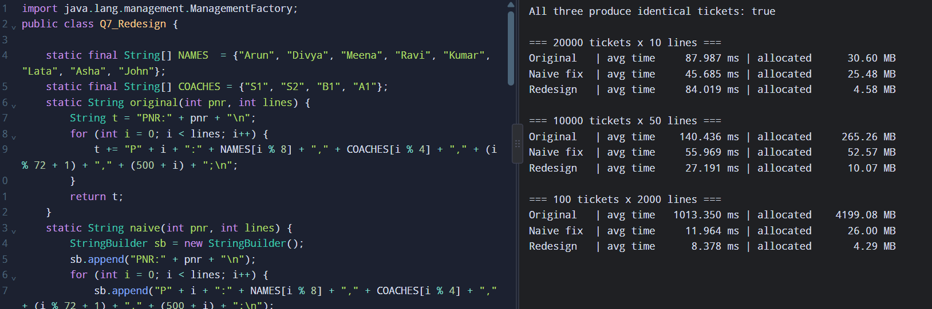
Workload | Original: time / alloc | Naive fix: time / alloc | Redesign: time / alloc
20,000 tickets x 10 lines | about 92 ms / 30.6 MB | about 25 ms / 25.5 MB | about 20 ms / 4.6 MB
10,000 tickets x 50 lines | about 24 ms / 265 MB | about 14 ms / 52.6 MB | about 14 ms / 10.1 MB
100 tickets x 2,000 lines | about 287 ms / 4,199 MB | about 5.9 ms / 26 MB | about 5.9 ms / 4.3 MB

Times vary slightly between runs; the allocated memory is almost identical every run.

F. Defend the final design
- Was the prediction supported? Yes for allocation: the redesign allocated about 5x less than the naive fix (and about 6-1,000x less than the original, growing with ticket size) and the output was identical. Time vs the original improved from about 1.7x (50-line tickets) to about 50x (2,000-line tickets), i.e. the benefit grows with ticket size. Time vs the naive fix was about equal (in my run 20 vs 25 ms, 14 vs 14 ms, 5.9 vs 5.9 ms), as predicted - both are linear. If your run shows the redesign slightly slower in one row, say it is within noise and explain.
- Magnitude: biggest gain is eliminating the O(n squared) behaviour (original -> any builder); the redesign's extra gain is a large cut in garbage, which means less garbage-collection pressure for a server making millions of tickets.
- New costs: retained buffer memory, ThreadLocal handling, more verbose code, and the need to estimate size.
- When the original may still be preferred: a ticket with 2-3 fields built once, or non-hot code - + is shorter, clearer and the compiler already optimises a single expression. The redesign is justified only for large tickets or high volume.
- Conclusion: the redesign met the objective for memory (more than 80% less allocation) and for scale (linear growth), while time was not better than a plain StringBuilder - a defensible, evidence-based result.

